Beauty Parlor Management System

- Project Overview
The Beauty Parlor Management System is full-stack Web application built using Flask(Python) and MySQL. The system is design to digitalize and automate the day-to-day operations of beauty parlor.
The application allows customer to browse available services, book appointment, make payments, and manage their booking online. At the same time, it provides administrators with powerful tools to manage services, bookings, appointments, and payments through a secure admin panel.
The project focuses on building a scalable, user-friendly, and secure platform that replaces traditional manual appointment handling with a modern web-based solution.

- Objective
  - Provide an easy and modern online appointment booking system
  - Eliminate manual appointment handling and paperwork
  - Reduces booking conflicts and scheduling errors
  - Provide centralized management of services and appointments
  - Improve overall efficiency of beauty parlor operations
  - Ensure secure authentication and role-based access
  - Provide a user-friendly web application through which they can book there appointments.

- Technology Used
  - Backend Technologies
    - Flask (Python): Used to build the server-side logic, routes, authentication, and business logic.
    - MySQL: Relational database used to store user, services, booking, and appointments.
  - Frontend Technologies
    - HTML: Structure of web page
    - CSS: Styling and Layout
    - JavaScript: Client-side interactivity and dynamic content
    - Bootstrap: Responsive and modern UI components

  - Other Tools & Concepts
    - Session-based Authentication

- Scope of the Project
  - In Scope
    - Admin authentication (login/logout)
    - Service management (CRUD)
    - Category-based services
    - Booking and appointment management
    - Admin calendar view
  - Out of Scope (Future Enhancements)
    - Online payment gateway integration
    - Customer mobile application
    - SMS/ WhatsApp notifications
  - System Users
    - Admin
      - Manage Services
      - Manage Appointments
      - View Calendar
      - Control Services and Category status(active/inactive)
    - Customer
      - View Services
      - Book Appointment
      - Make Payment
      - Check they current appointment and history

- Database Table Details
  - Users Table
    - ID
    - Client Name
    - Registration ID
    - Address Id
    - Contact Id
  - Service Table
    - ID
    - Service Name
    - Charges
    - Durations
    - Gender ID
    - Category ID
    - Service Type ID
    - Status
  - Appointment Table
    - Appointment ID
    - Booking ID
    - Payment ID
    - Staff ID
    - Appointment Date
    - Appointment Time
    - Status
  - Booking Table
    - Booking ID
    - Client ID
    - Client Name
    - Client Email
    - Client phone
    - Booking Date
    - Booking Time
    - Service Type
    - Total Amount
    - Status
    - Payment Status
  - Booking Services
    - ID
    - Booking ID
    - Service ID
  - Category
    - ID
    - Category Name
    - Status(1 or 0)
  - Contact Table
    - ID
    - Phone Email
  - Address Table
    - ID
    - Street
    - City
    - State
    - Pin code
  - Gender Table
    - ID
    - Name (Men/Women)
  - Payment Table
    - ID
    - Booking ID
    - Amount
    - Payment Email
    - Payment Method
    - Payment Time
    - Payment Status
    - Transaction ID
    - Updated At
  - Registration Page
    - ID
    - Full Name
    - Email
    - Password (in Hash form)
    - Role (Client/Admin)
  - Service Table
    - ID
    - Name
    - Charges
    - Duration
    - Gender ID
    - Category ID
    - Service Type ID
    - Status
  - Service Type Table
    - ID
    - Name (Normal/Groom/Bridal)
  - There are some other more table like :- Review, Staff, Products, Seller.

- Database Design (High Level)
  - Key Tables
    - Users - Admin Authentication
    - Services – Service Details
    - Categories – Service Categorization
    - Bookings – Booking Records
    - Appointment – Confirmed Appointments

- System Modules (Level 1)
  - Service Module
    - The Service Module all beauty parlor services offered to customers. Services are organized by Categories and service types (Normal, Groom, Bridal)
    - Main Functions:
      - Select one or multiple services from service
      - Define Price and Time Duration
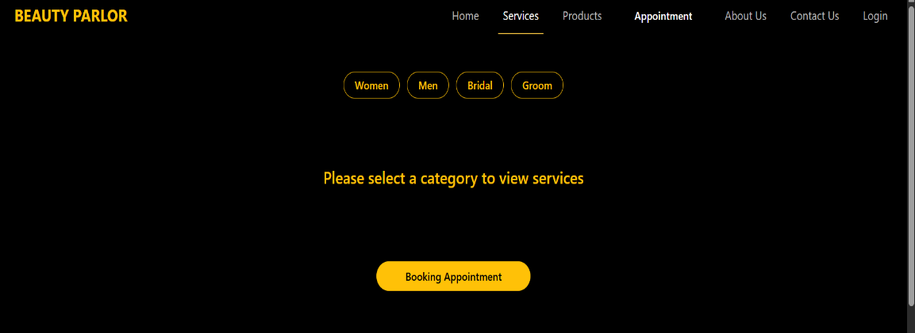
      - This module ensures structured service management and accurate pricing information.
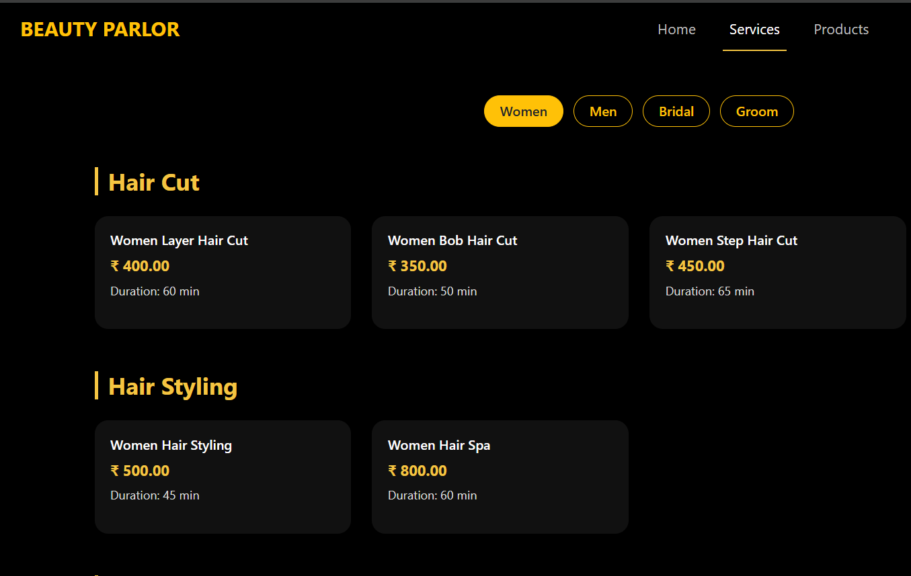

  - Booking Module
    - The Booking Modules the initial stage of the custormer appointment process.
    - Main Functions:
      - Customer select services and preferred date/time
      - System store booking details
      - Calculates total service amount
      - Maintains booking status(Pending/Paid/Cancelled)
      - This module separate booking from appointment confirmation to maintain better data integrity.

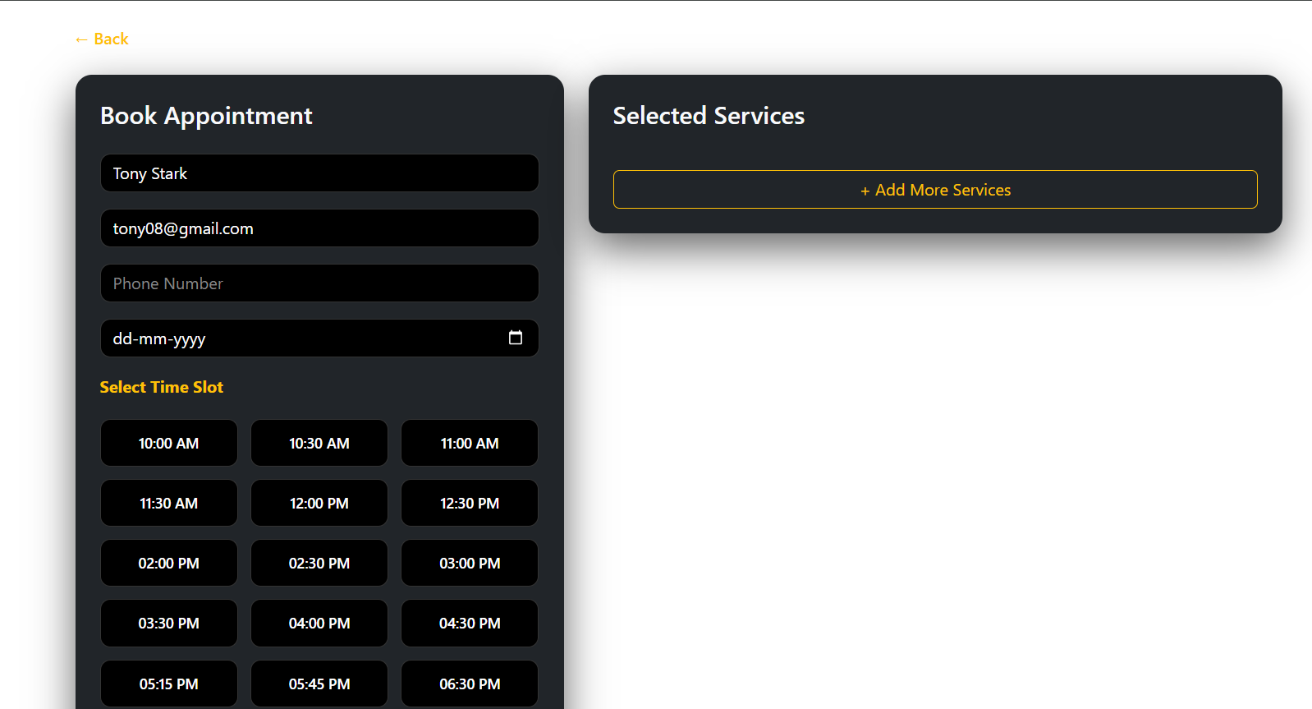
  - Appointment Module
    - The Appointment Module and manages scheduled services.
    - Main Functions:
      - Generate appointment after successful payment
      - Displays data-wise appointment in admin panel
      - Update appointment(Confirmed/Completed/Cancelled)
      - Prevents scheduling conflicts
    - This module is the core scheduling system of the application.
  - Payment Module
    - The Payment Module manage payment tracking for bookings.
    - Main Functions:
      - Store payment status
      - Links payment with booking record
      - Tracks total revenue (monthly/yearly- future enhancement)
    - Currently, payment logic is structure in the database and workflow. Full payment gateway integration is planned for future updates

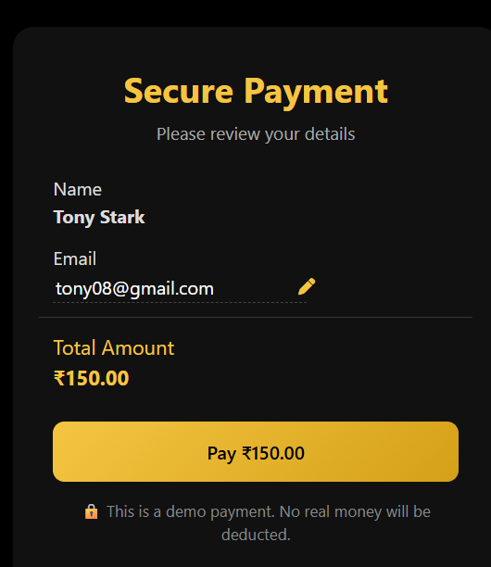

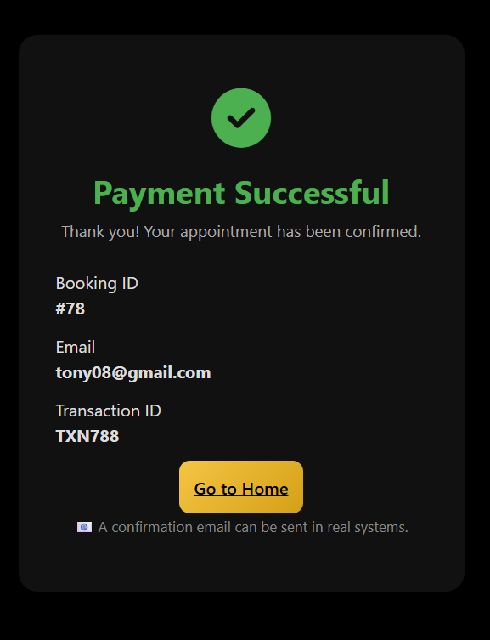

- Admin Panel Module
  - The Admin Panel cats as the central control unit of the Beauty Parlor Management System. It provides complete authority to monitor, manage, and analyze all operational activities of the beauty parlor.
  - The admin panel is divided into multiple functional sections as described below:
    - Dashboard
      - The Dashboard provides a summarize overview of system performance.
      - Features:
        - Total Booking count
        - Total Appointment count
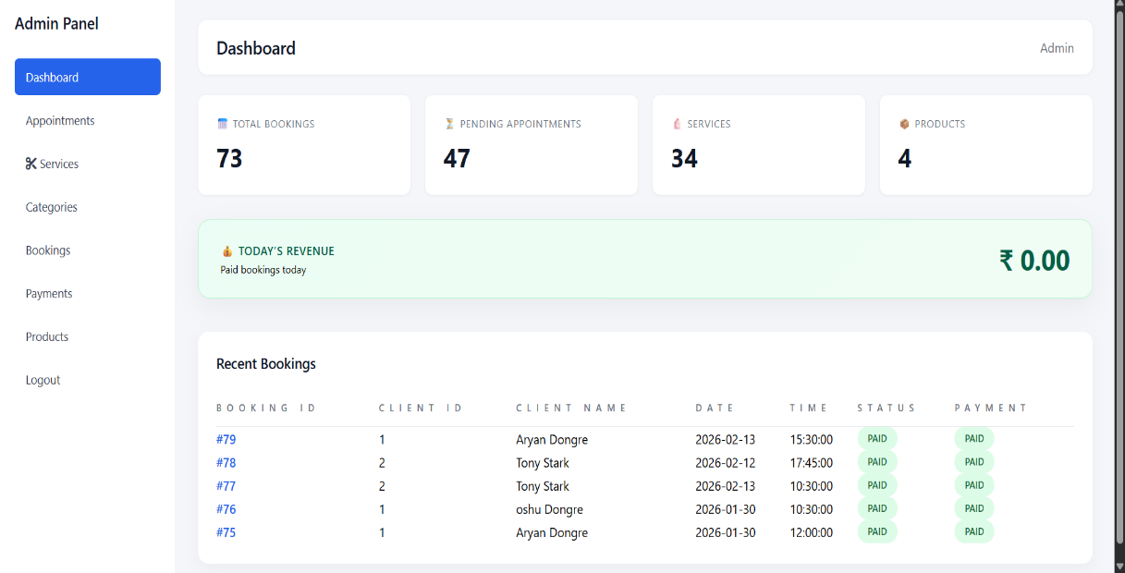
        - Total Services count
        - Total Product count
        - Total Today revenue
        - Display of Recent Bookings
        - Quick statistic view for decision-making
      - This section helps the admin quickly current system activity.
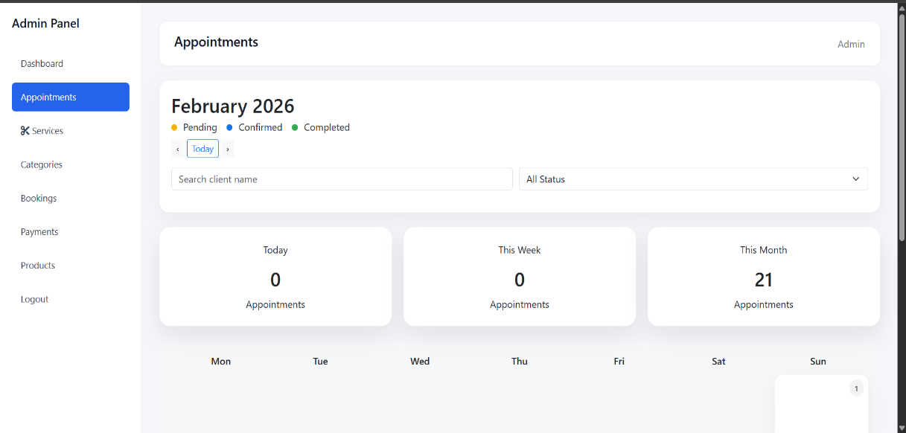
    - Appointment Section (Calendar-Based System)
      - This module provides a calendar interface to manage appointments efficiently.
      - Features:
        - Calendar view of all appointments.
        - Status indicators: Confirmed, Pending, Cancelled
        - Clickable date-based appointment details
        - Search and filter system(by customer name or status)
        - Real-time status updates
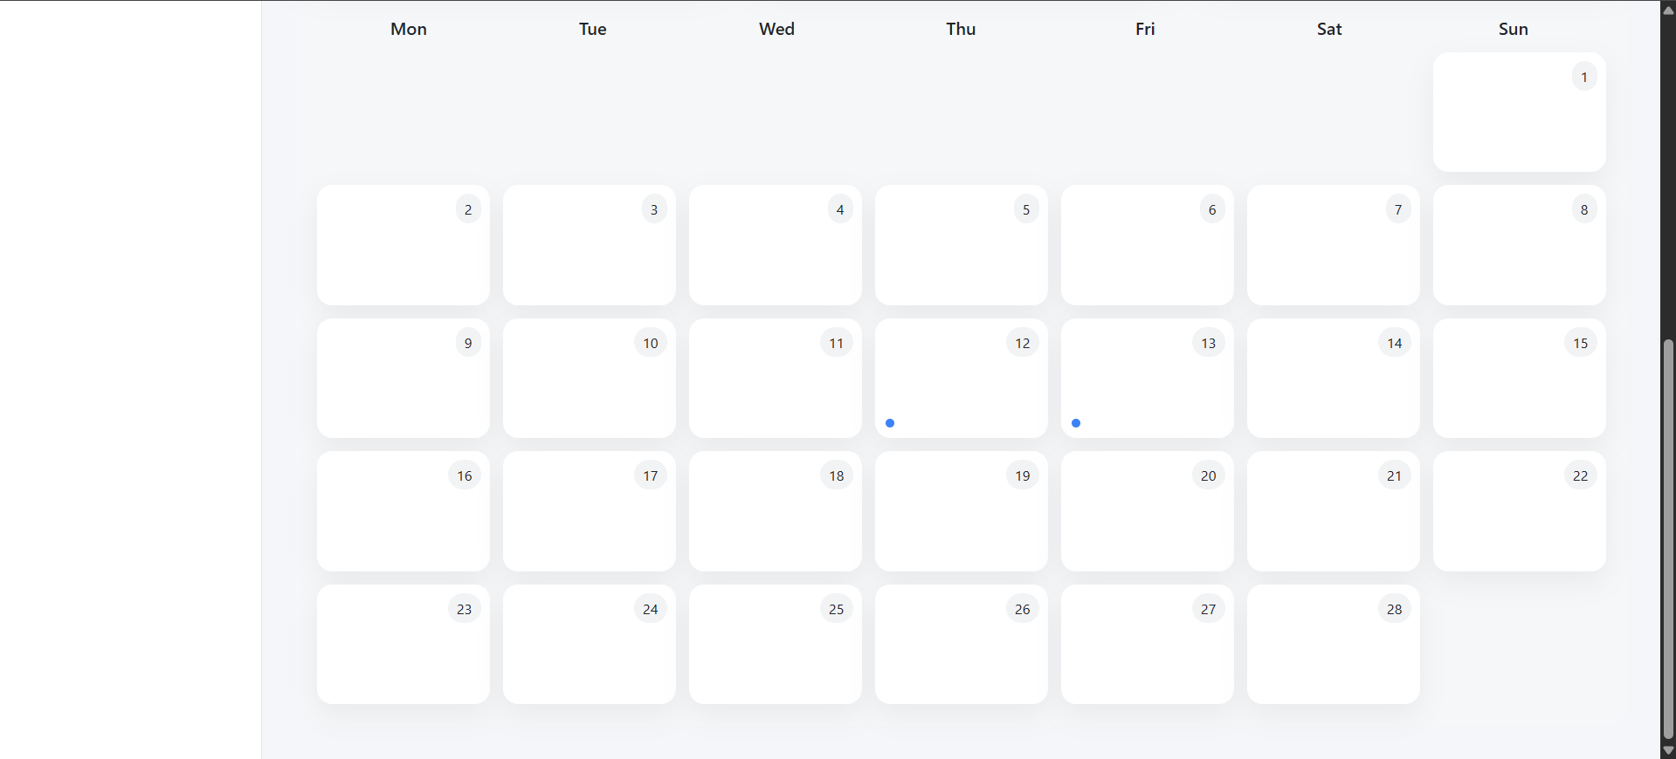
      - This ensures proper scheduling and prevents appointment conflicts.
    - Service Section
      - The Service section is divided into two main sub-parts:
Service Analysis
        - This area provides graphical insights into service data.
        - Graphs Included:
          - Service Status Distribution
          - Service Type Distribution (NORMAL / GROOM /BRIDAL)
          - Most Booked Services
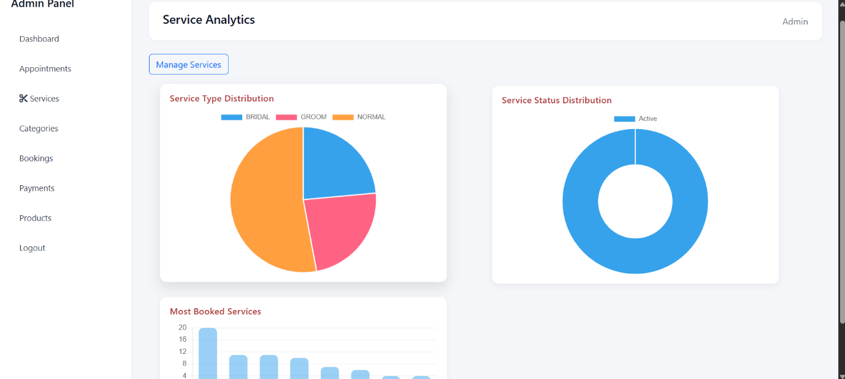
        - These analytics help the admin understand customer treads and service demand.
Manage Service
        - This area allows full control over service records.
        - Features:
          - View all active services with name, price, duration, and category
          - Add new service
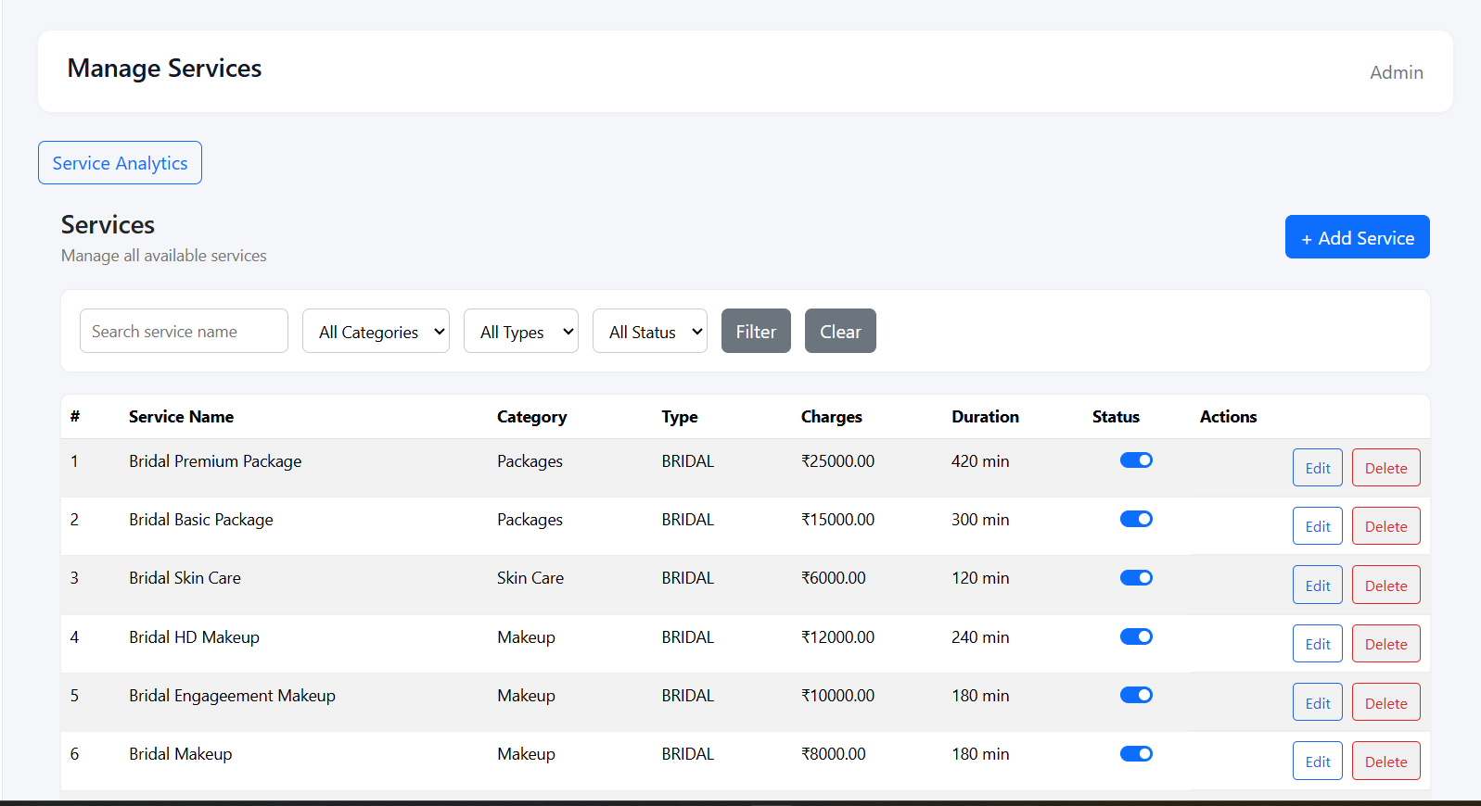
          - Edit existing service
          - Delete service
          - Enable/Disable service status
    - Category Section
      - This section manage service categories
      - Features:
        - View category list with active/inactive status
        - Add new category
        - Edit category details
        - Maintain service type classification
      - Categories help organize services properly within the system.
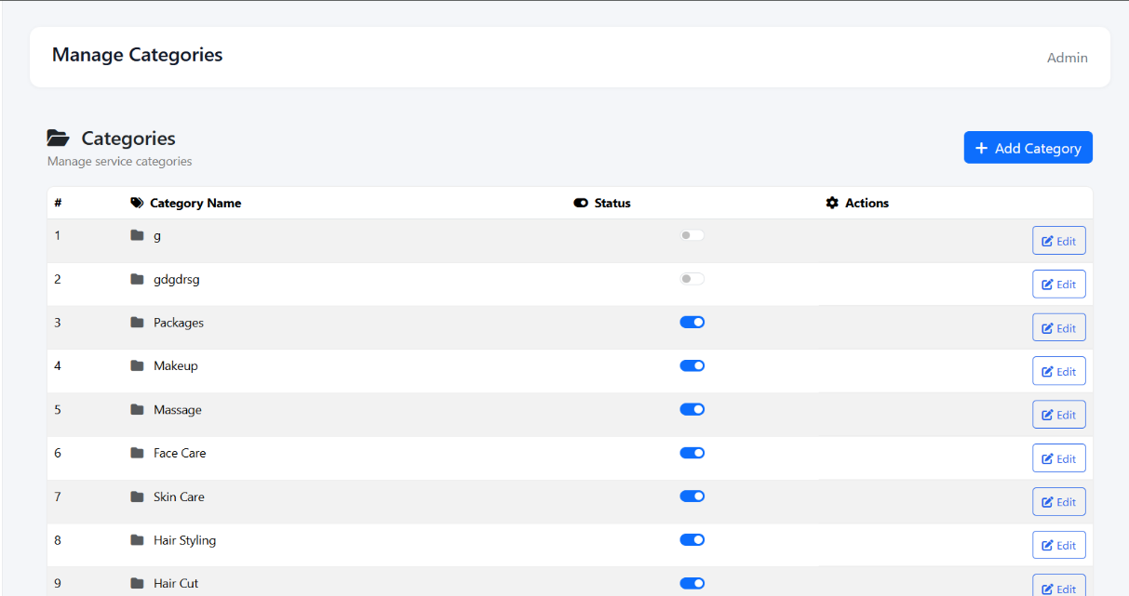

    - Booking Section
      - This section manages all customer bookings.
      - Features:
        - Total Bookings count
        - Paid Bookings count
        - Pending Bookings count
        - Total Revenue calculation
        - Detailed booking table (customer info, date, amount, status)
        - Filter system (by name, status, or date)
      - This module ensures proper tracking of financial and customer records.
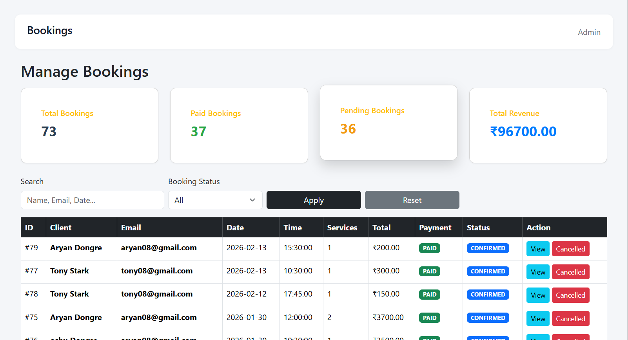

    - Product Section
      - The Product section manages beauty product available in the system.
      - Features:
        - View product list with details
        - Add new product
        - Edit product information
        - Delete product
        - Manage product availability status
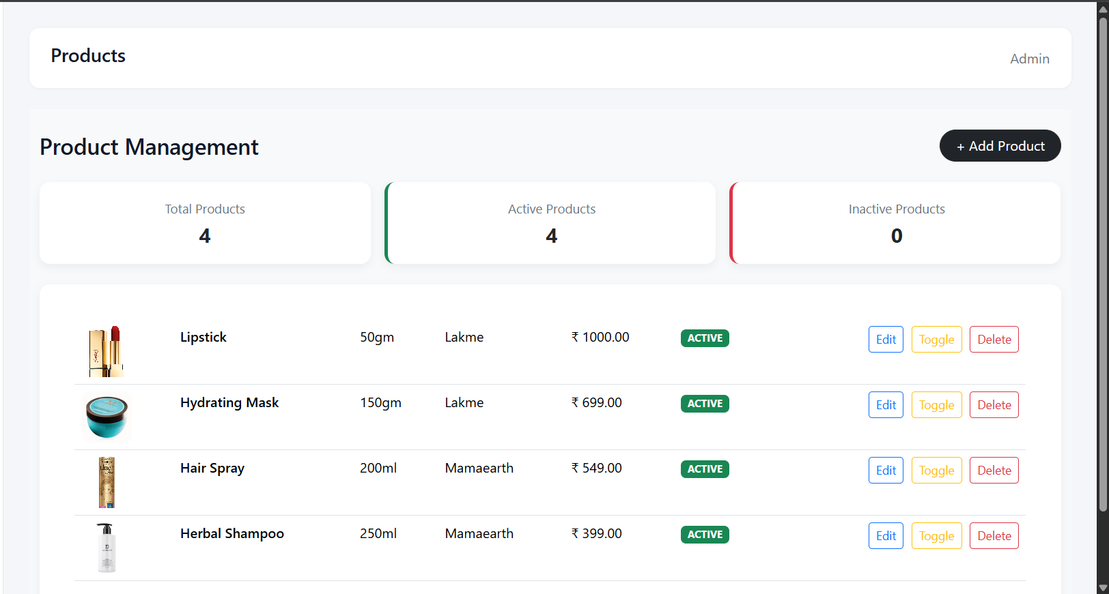
      - The Admin Panel collectively provides full operational, analytical, and financial control over the beauty parlor system

    - Payment Section
      - In this Admin we get all the Revenue information like Total Revenue , Today Revenue, Month Revenue and Total Transactions.
      - All with that Admin we get the graph representation through which the Parlor earning more and there is a monthly graph also which show how much they earn in month.
      - Feature
        - Proper Card Style
        - Proper Graph representation
        - Client Payment Details with time, amount status.
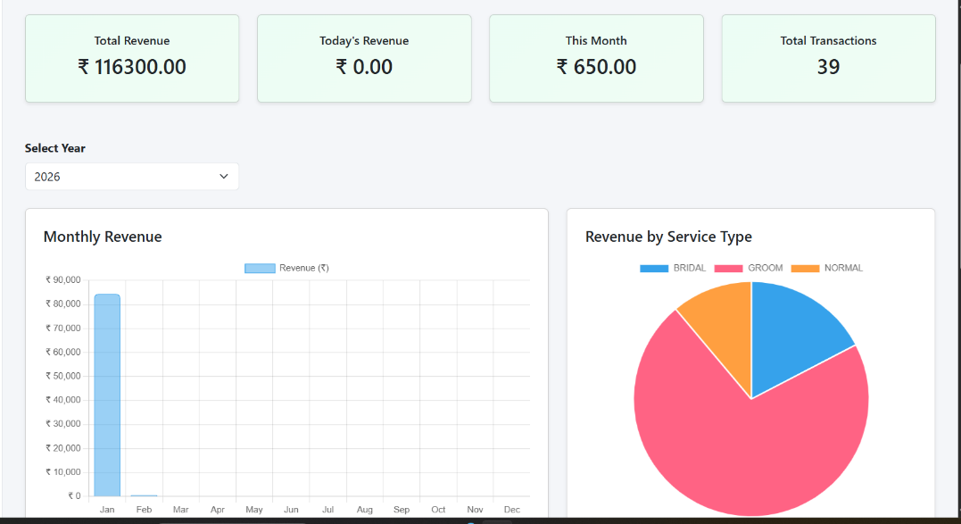

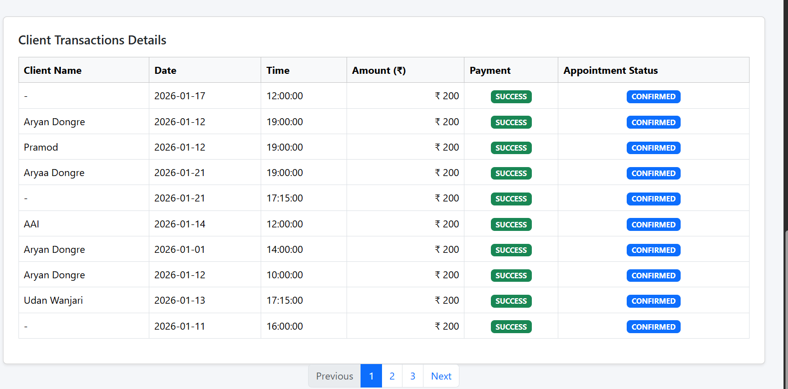

8. System Data Flow (Booking → Payment → Appointment)
The Beauty Parlor Management System follows a structure and logic workflow to ensure smooth and error-free appointment handling. The process is divided into three main stages:
Step 1: Service Selection
- Customer browses the available services
- Select desired services
- The Services are mention with the price and time
- The System calculate the total amount based on the selected services.
Step 2: Booking Creation
- System creates a booking record in the database
- Booking status is initially set a PENDING
- Booking details include Client information, Date and Time, Selected Services, and Total Amount
- At this stage, the appointment is NOT yet confirmed.
Step 3: Payment Processing
- Customer complete payment
- Payment status is updated in booking table
- Booking status change from PENDING to PAID
- Only after successful payment does the system proceed to appointment confirmation.
Step 4: Appointment Confirmation
- System generates a new record in the appointments table
- Appointment is linked to the booking ID
- Appointment status is set to Confirmed
- Admin can view appointment in calendar/dashboard
- This separation between booking and appointment improves data integrity and prevents fake or unpaid appointment confirmations.
Benefits of This Flow
- Prevents scheduling conflicts
- Ensures payment validation before confirmation
- Maintains clean database relationships
- Improves scalability for future features

